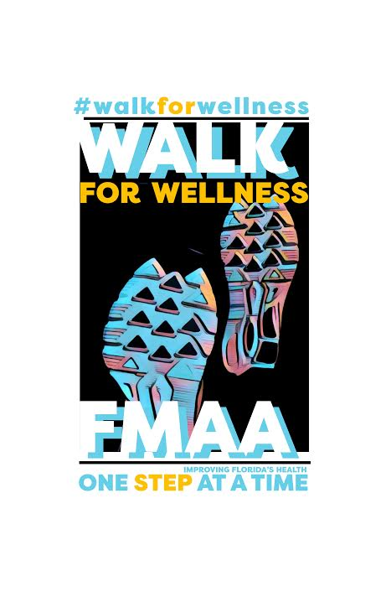

JOIN SCMSA AS WE PARTICIPATE
IN THE FMAA’S WALK FOR WELLNESS

SATURDAY, FEBRUARY 3, 2018
8:45 AM
BAYFRONT PARK IN SARASOTA

WE WILL WALK AS A GROUP OVER THE RINGLING BRIDGE AND BACK. BRING YOUR SPOUSE AND KIDS!

THIS IS A FUN AND INFORMAL EVENT DESIGNED TO GET US ALL MOVING TOWARD BETTER HEALTH!

THE FMAA WILL BE PROVIDING ALL PARTICPATING MEMBERS WITH A
T-SHIRT FEATURING THE WALK FOR WELLNESS LOGO. LIGHT REFRESHENTS WILL BE PROVIDED.

EMAIL ANGELA ABRAMS AT ANGELAHEWING@GMAIL IF YOU WOULD LIKE TO PARTICPATE!

