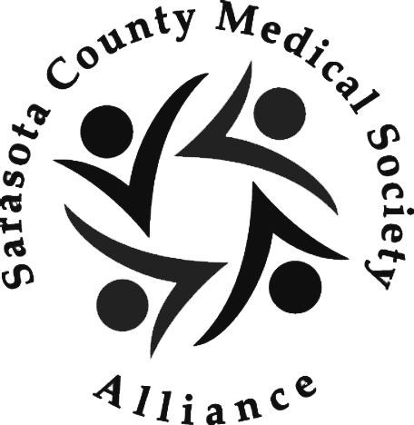Sarasota County Medical Society Alliance
www.myscmsa.org
Dear Membership Candidate:
Please complete this form and join us today! We look forward to having you in the Alliance!
Our annual membership dues are as follows (choose one):
- Standard, Sarasota County Medical Society Alliance $50 _____
-Premium, Both S.C.M.S.A. and the Florida Medical Assoc. Alliance (FMAA) $100 _____
Please make check payable to: S.C.M.S.A. or use credit card (M/C, Visa, AmEx).
Credit card type ________Card#: _____________________________________________________Exp. _________ Code_______
Or mail to: SCMSA ℅ Priya Acharya, 3762 Eagle Hammock Dr. Sarasota, FL 34240
Or Fax: (941)929-9800 (with credit card info)
You will be listed in a printed directory and a password-protected membership area of our website.
Name ___________________________________________________Specialty (if you are a physician) ___________________
Spouse’s name_________________________________________________ his/her med. specialty_______________________
Your email ____________________________________________________________________ Cell _____________________________
Home phone ___________________ Home address ________________________________________________________________
Ages of children (optional)_____________________________________________________________________________________
Special job skill or talent you would like to share (ie, accounting, computers, marketing, teaching, etc.)____________________________________________________________________________________________________________________Please mark if you may be interested in participating in any of our social clubs:
_______ Moms and baby/toddler playgroup _______ Bunco Club (once a month- Girls Night Out)
_______ Book Club (daytime once a month) _____ I have new club suggestion. If so, describe. __________________________________________________________________________________
_______ My physician spouse may be interested in TV participation or engaging a special event to support our physicianadvocateaward.org program (RX abuse and misuse) campaign.
Best Regards,

Ricki Rubin
Membership Chair, rickivolunteer@gmail.com, cell (941) 448-1632, (941)580-6670

